Introduction to Community
Social Pediatrics
- SLIDE PRINTOUT –

COURSE DESCRIPTION
À travers l’histoire de cas de la jeune Mélissa, découvrez les différentes étapes que traversent tous les enfants en pédiatrie sociale en communauté. Pendant ce parcours immersif, les thématiques majeures, la démarche clinique, le continuum de services, les particularités du modèle, la philosophie et les valeurs de l’approche de pédiatrie sociale en communauté seront présentés.

OBJECTIVES
- Understand the key concepts underlying CSP
- Become familiar with the different steps in the service continuum
- Identify the values specific to CSP

DESCRIPTION OF THE SLIDE PRINTOUT
We encourage you to make digital notes on your copy of the slide printout as you go through the training session. If you find some of the images too small, you can enlarge them by selecting them and dragging on a corner of the image. You can also zoom out to enlarge the page. This function is usually located in the lower right corner of your text editing software (e.g., Word).

Enjoy the training session!

MODULE 1: Defining Community social pediatrics
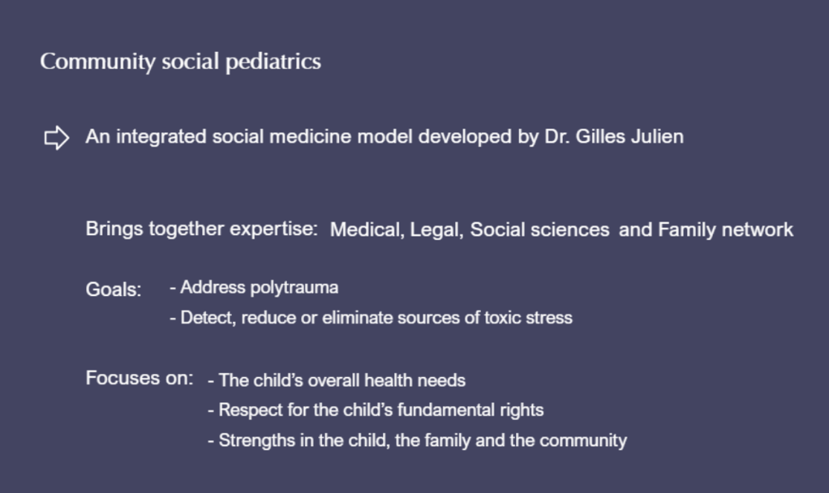
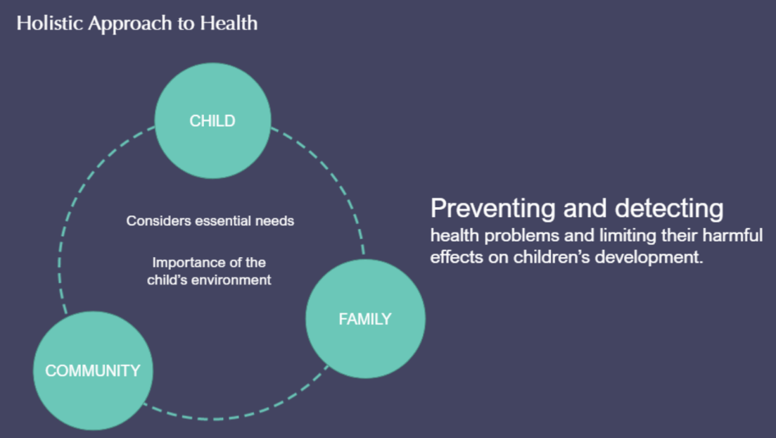
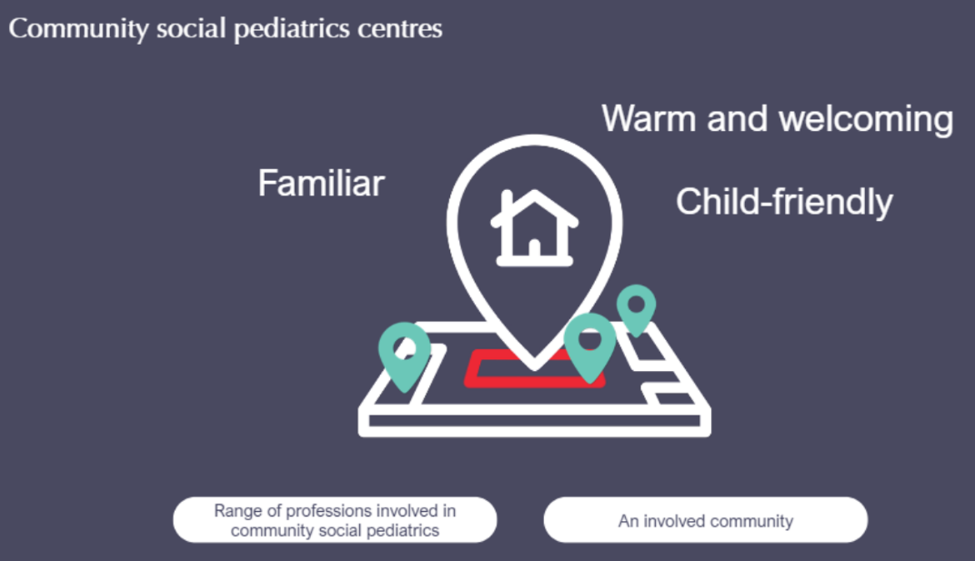

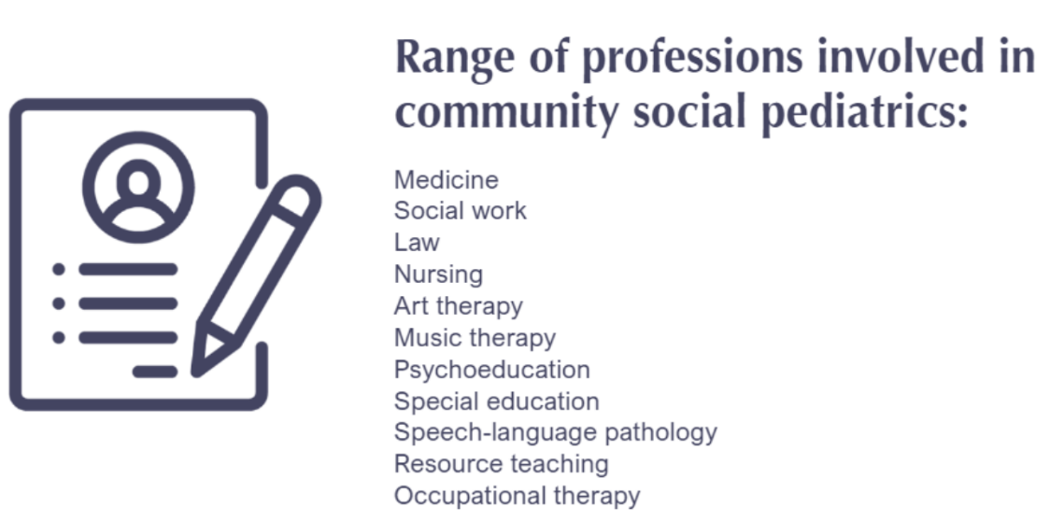
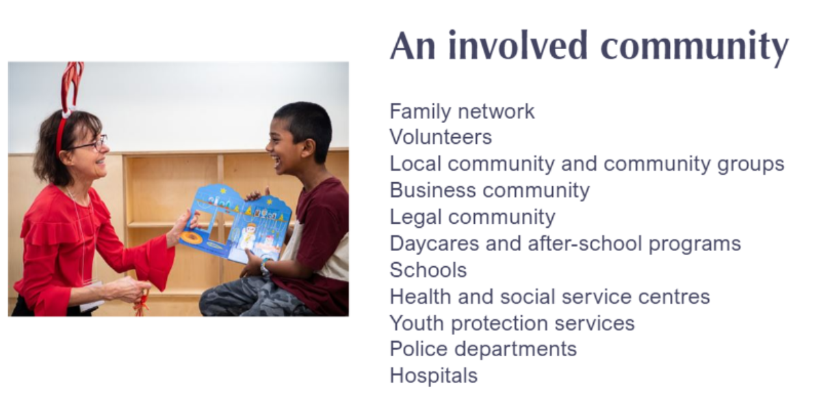
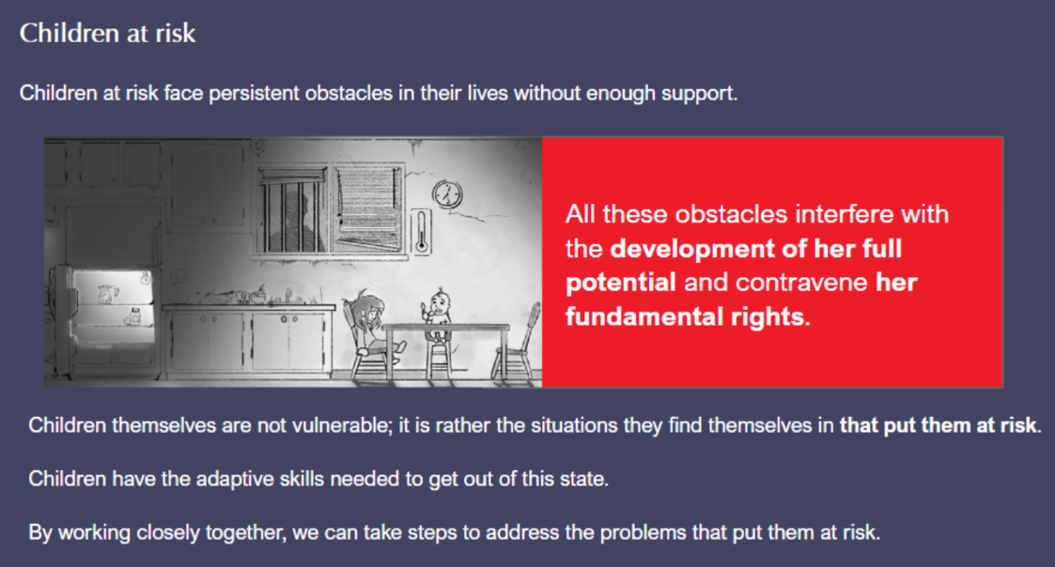
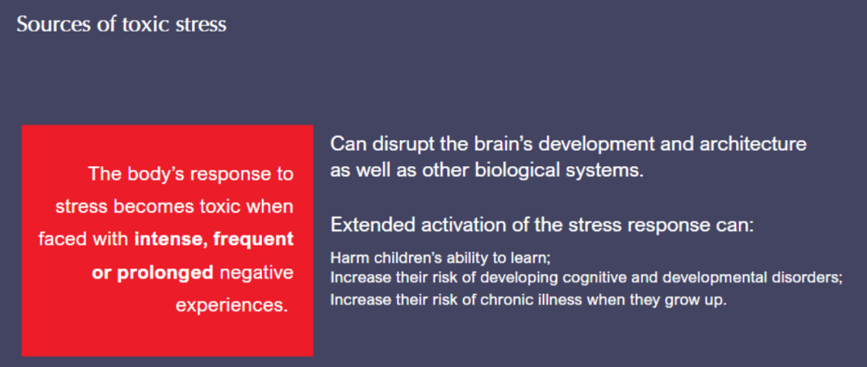
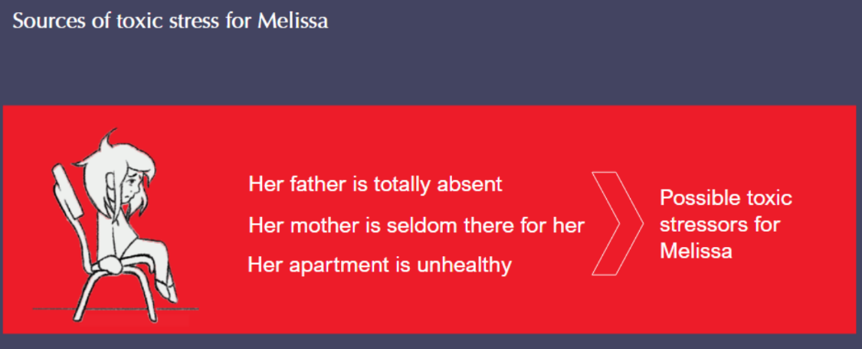
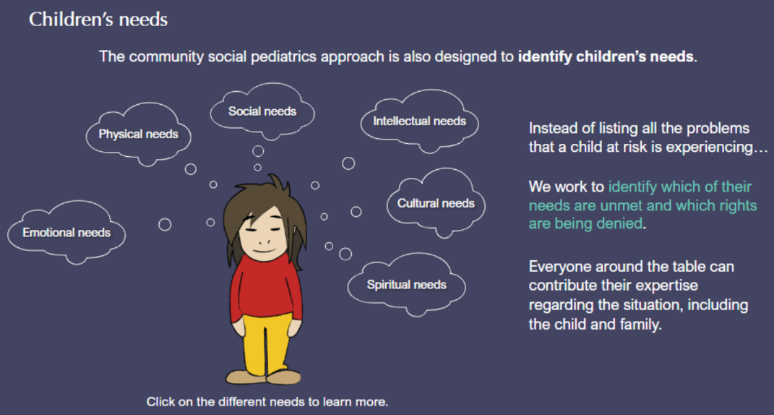
Physical needs:
Melissa needs to have a healthy body and grow up in a healthy environment where she can develop her full potential.

Social needs:
Melissa needs to build trusting relationships with friends and family and have positive social interactions with others so she can create a network she can count on.

Intellectual needs:
Melissa needs to develop her intellectual abilities to understand the world around her and lead a fulfilling life.

Emotional needs:
Melissa needs to feel loved, important, appreciated, respected, grounded and tied to a family and a community.

Cultural needs:
Melissa needs to belong to a culture, to have an identity, a language and values.

Spiritual needs:
Melissa needs to see and bring meaning into her life.

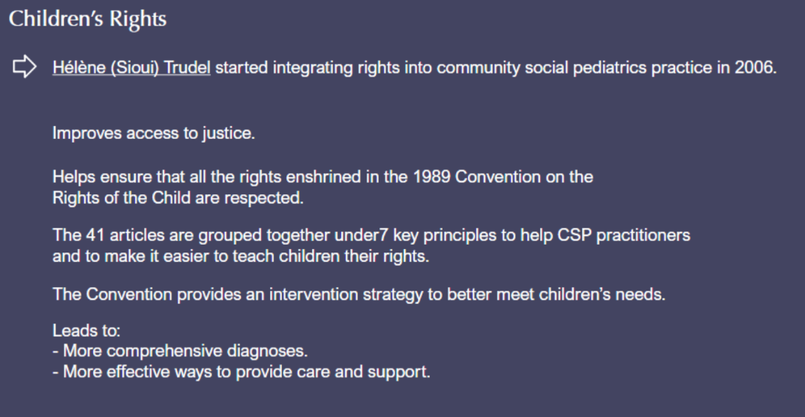
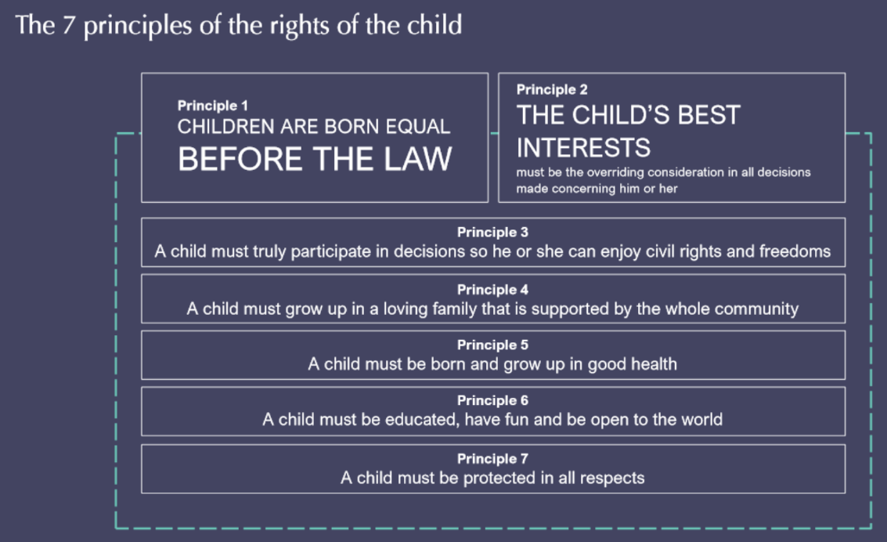
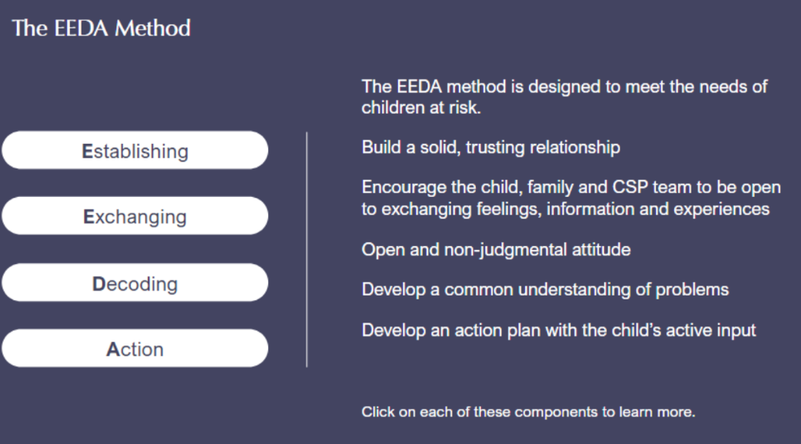
Establishing involves:

- Entering each other’s world
- Starting to feel comfortable with each other
- Establishing a basis for working together

In actual practice, this means:
- Welcoming the child and family in a friendly, informal and non-judgmental atmosphere.
- Making the child and family feel comfortable and open to discussion through warm physical contact, sharing food and offering small, token gifts.

Exchanging involves:
- Opening up to others with no preconceived notions around facts, ideas and attitudes regarding the child

In actual practice, this means:
- Leading the discussion among all participants around the table
- Gathering information on the child’s developmental and family’s genetic history
- Exploring the child’s needs and sources of toxic stress
- Identifying strengths in the child, family and community
- Asking questions and developing hypotheses
- Taking a comprehensive and complete history

Decoding involves:
- Working together to analyze everyone’s understanding and experiences
- Understanding the meaning of a problem
- Deciding what steps to take next

In actual practice, this means:
- Understanding the information gathered
- Examining the child
- Determining possible diagnoses based on the information collected
- Confirming possible solutions with everyone around the table

Action involves:
- Setting up mechanisms that treat, calm and restore balance, given the sources of toxic stress.

- Mobilizing the child’s community to come up with a support system the child can rely on.

In actual practice, this means:
- Summarizing the steps that need to be taken
- Prioritizing actions and solutions
- Developing an intervention plan
- Clearly spelling out the integrated plan tailored to the child’s needs

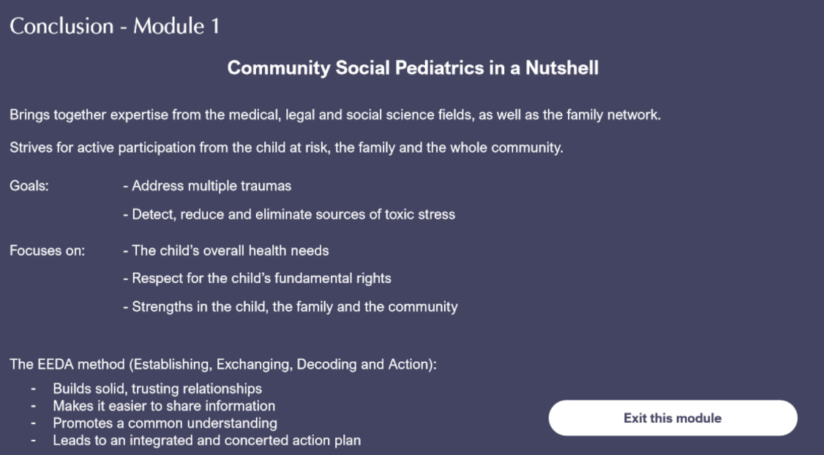

Module 2 : Assessment/Course of Action
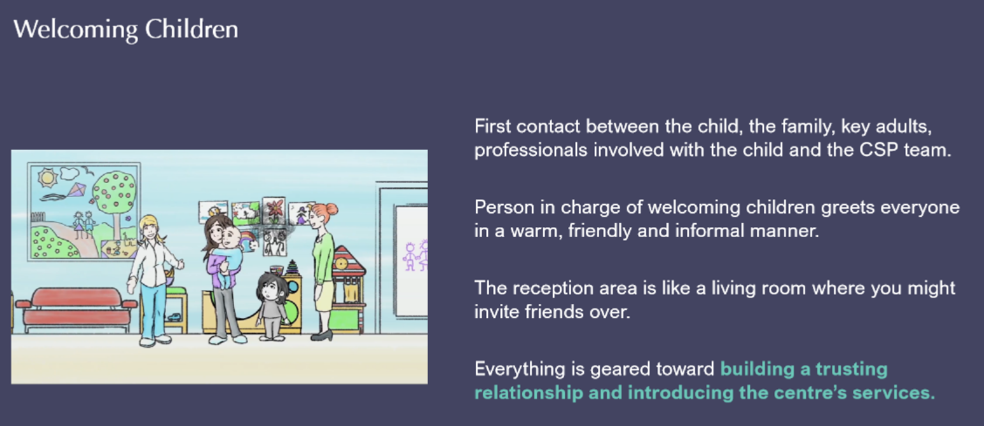
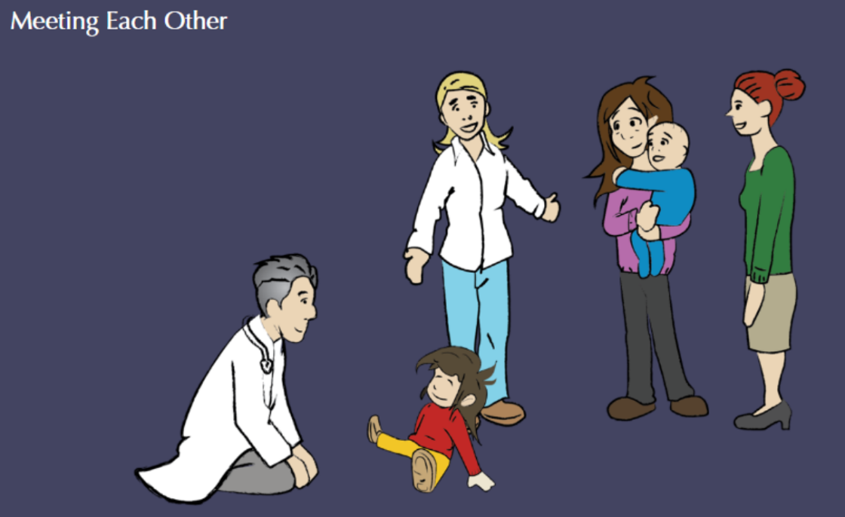
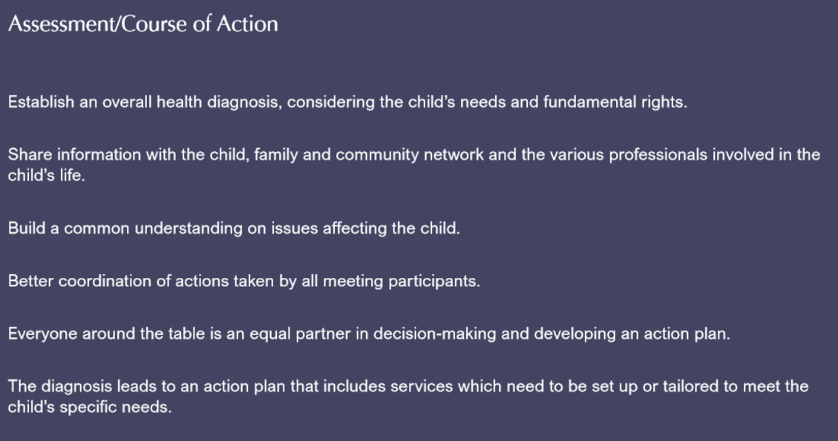
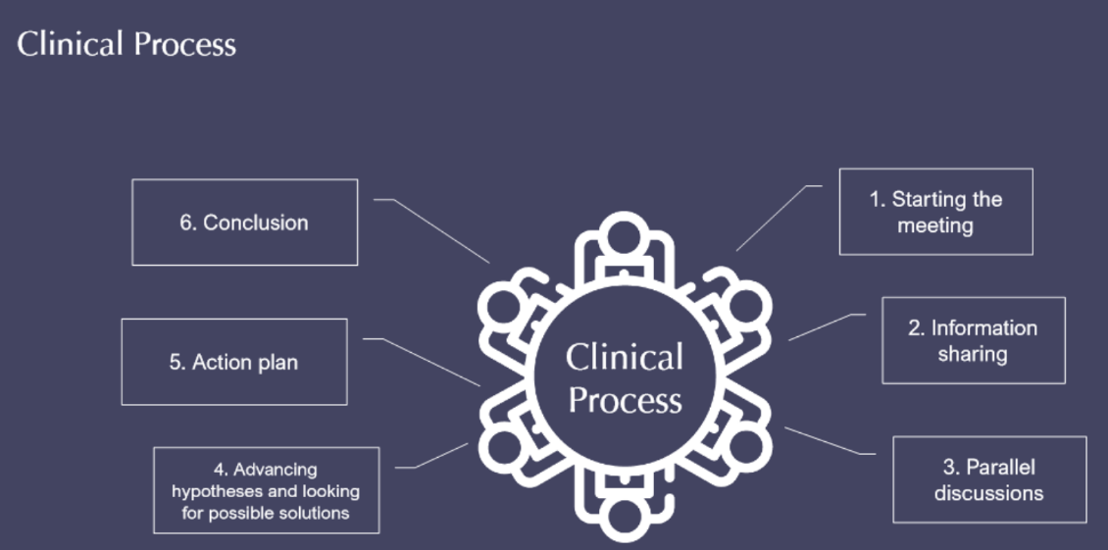
Starting the meeting
The doctor sits in a spot where he or she can easily observe the child. The social worker sits down wherever it makes sense, given the dynamics among the participants.

A member of the team opens the discussion by asking everyone to introduce themselves and explains how the meeting will proceed.

Information sharing
The clinical team’s aim is to understand the child’s and the family’s situation by exchanging information among all participants. The goal is to go over the child’s medical, family, social and developmental history.

The child explains the situation in his or her own words. The idea is to foster dialogue among all participants, rather than question each person separately.

Parallel discussions
For this part of the clinical process, the doctor takes the child to the examining table while the social worker stays with the other participants around the table.

The doctor continues talking with the child during the physical examination so that he or she can get a better sense of the child’s needs.

At the same time, the social worker brings the discussion back to some issues and ideas that have come up in order to better understand the origins of the child’s difficulties.

Secrets or important information that have surfaced during the conversation between the doctor and the child may be shared with the child’s permission.

Advancing hypotheses and looking for possible solutions
Information sharing leads to a common understanding in a totally transparent way. Everyone around the table is then positioned to contribute to a better understanding of what the child is truly going through and to suggest and help find solutions.

Action plan
Once hypotheses and ideas for possible solutions have been suggested, the community social pediatrics team summarizes the various hypotheses and solutions brought up during the discussion.
The doctor establishes a diagnosis of health-related issues and an action plan is formulated based on agreed-upon priorities. The diagnosis may become clearer over time and in following the child’s lifecourse trajectory.

Conclusion
The conclusion occurs when solutions or potential solutions have been found in response to the issues that have been raised during the meeting. The doctor checks whether the child’s and the family’s expectations have been met and the social worker will manage short- to medium-term follow-up from the meeting.
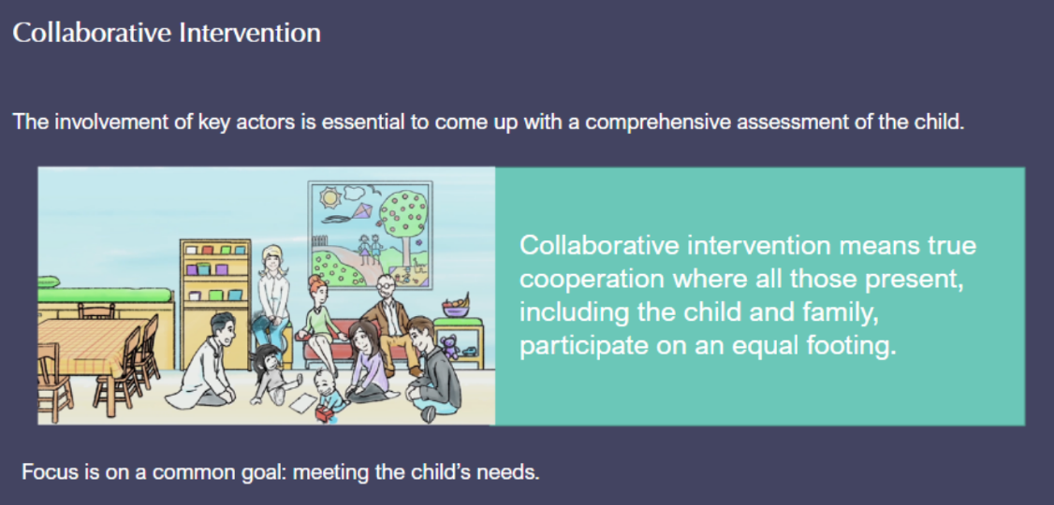
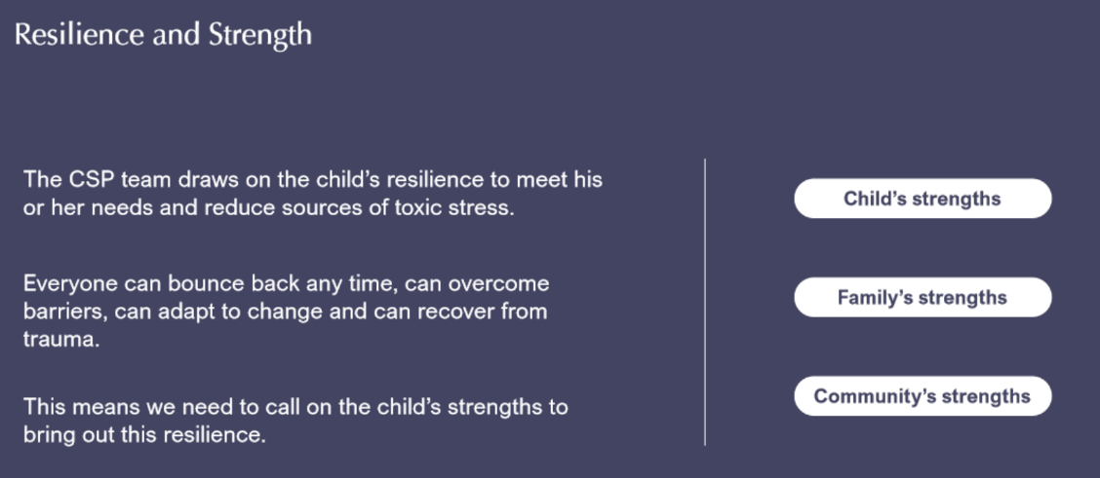
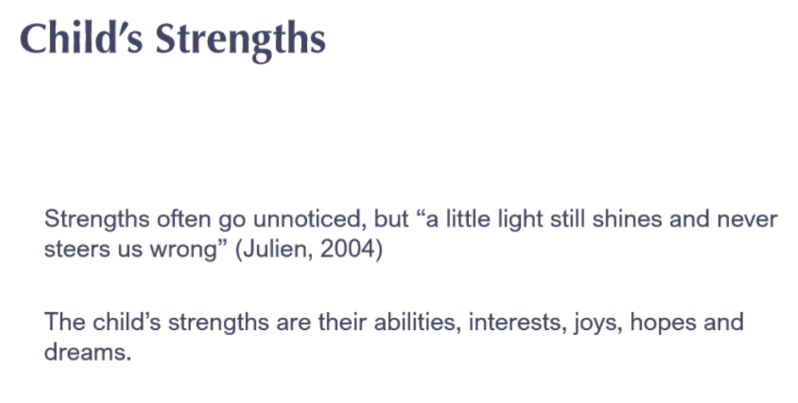
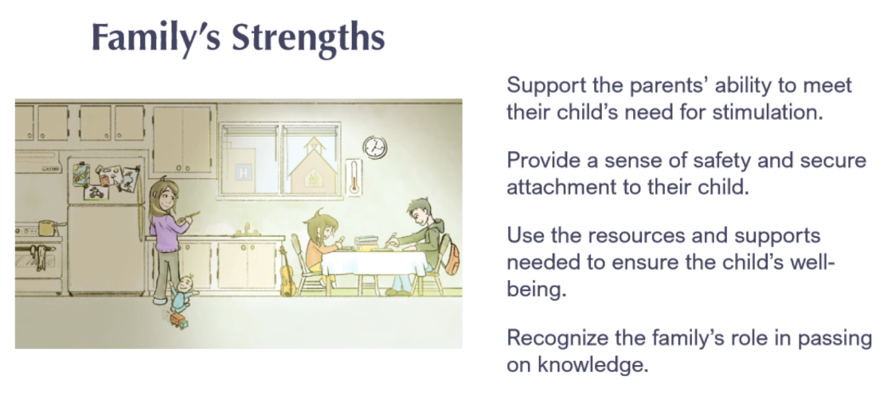
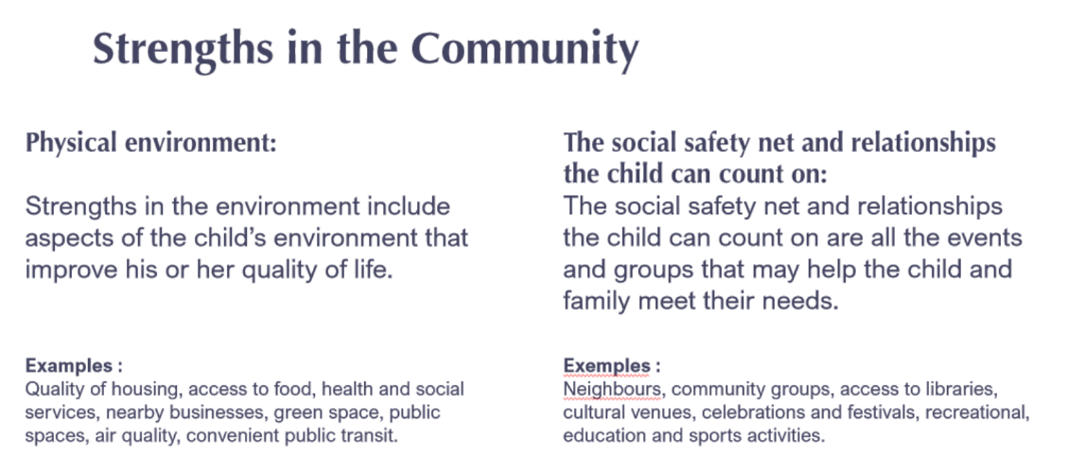
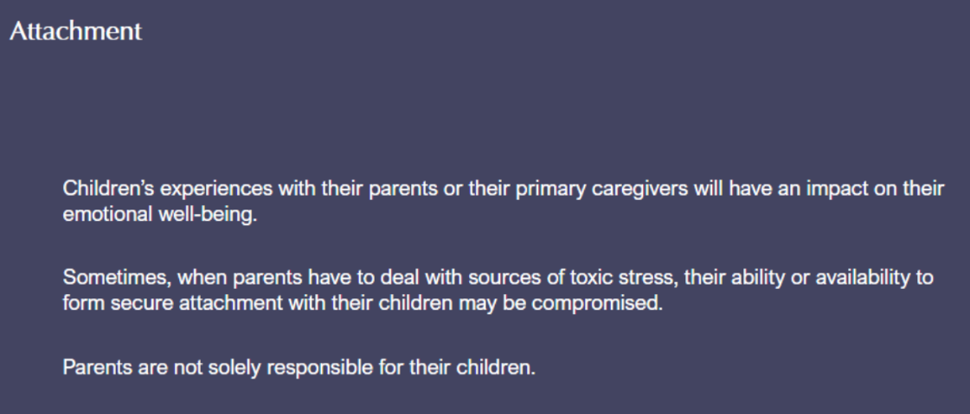
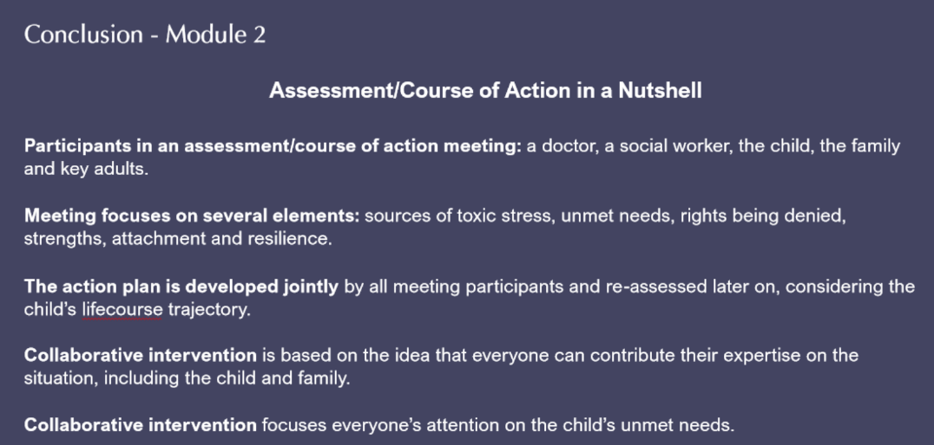

Module 3: Follow-up/Ongoing Care and Support
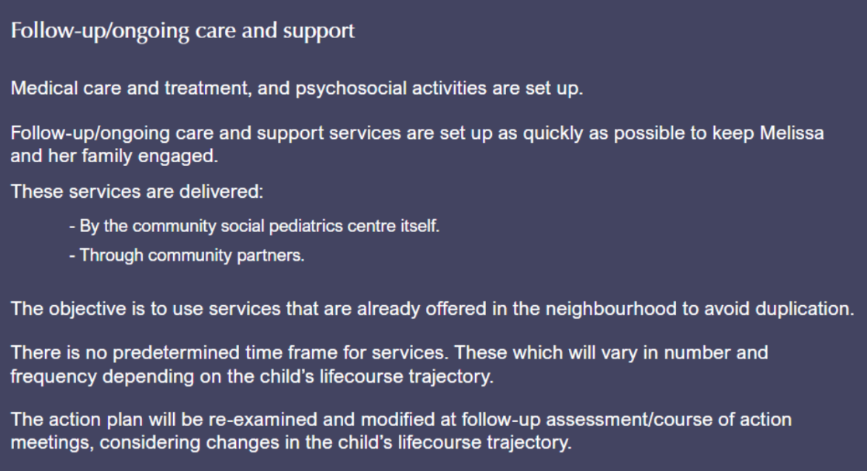
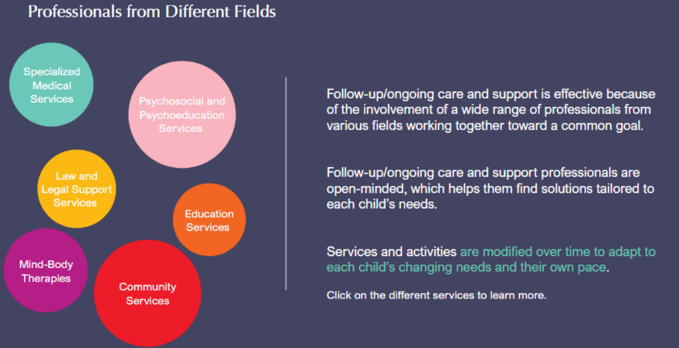
Specialized Medical Services
- Usually set up through service corridors developed between CSP centres and local institutions.
- Goal is to make sure children can have direct and prompt access to more in-depth assessments.
- Services include child psychiatry, neuropsychology, psychology, speech-language pathology and occupational therapy.

Psychosocial and Psychoeducation Services
- Services quickly set up and provided by the community social pediatrics centre itself.
- Delivered by social workers and psychoeducators.
- Play a pivotal role getting many different people involved to help the child.

Mind-Body Therapies
- Often offered at the community social pediatrics centre itself.
- Include mainly art and music therapy.
- Useful to help rebuild attachments, reduce stress and anxiety, and treat complex traumas.

Law and Legal Support Services
- Law and medicine come together in community social pediatrics practice. Legal support services are provided by a lawyer-mediator, ideally at the centre itself.
- Services offered include: legal advice, negotiation, mediation and close collaboration with a network of lawyers who work pro bono on contentious files.

Education Services
- Usually offered at the community social pediatrics centre itself.
- Delivered by special education professionals.
- The group or individual activities set up are designed to meet the clinical goals identified for each child.
- The CSP centre becomes a go-to place for the child and an additional safety net in times of crisis.

Community Services
- Enhance actions taken by the community social pediatrics centre, either through use of volunteers or community groups.
- Help form a protective circle around the child.

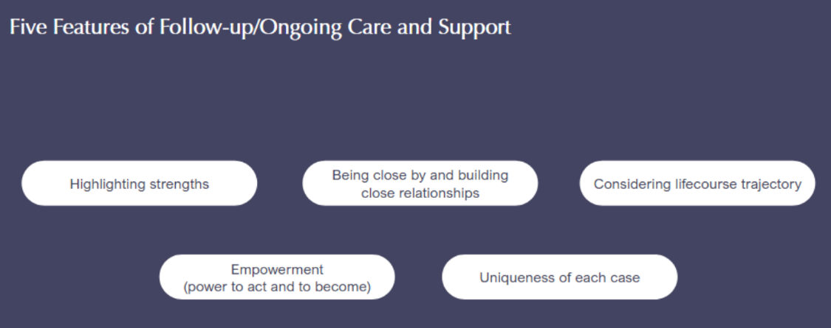
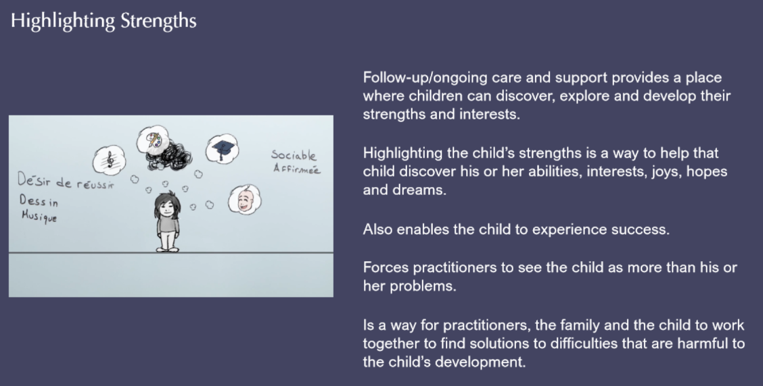
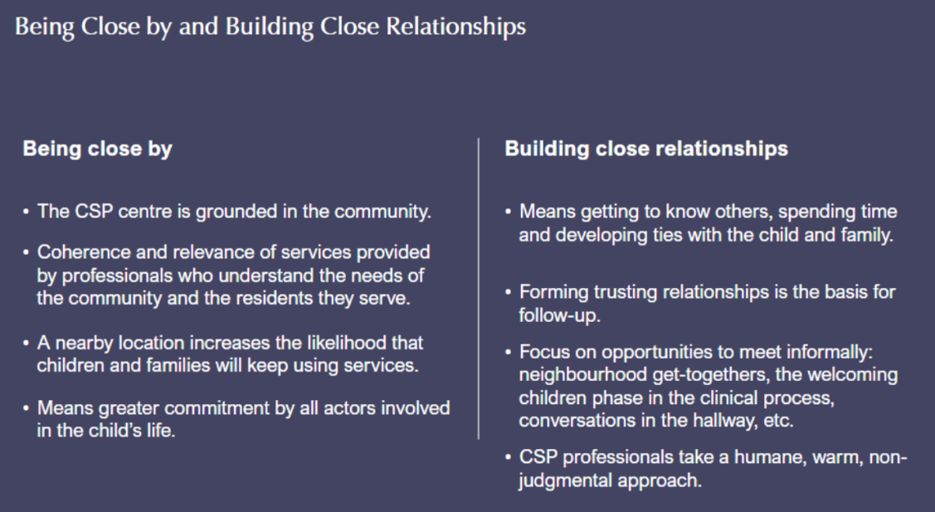
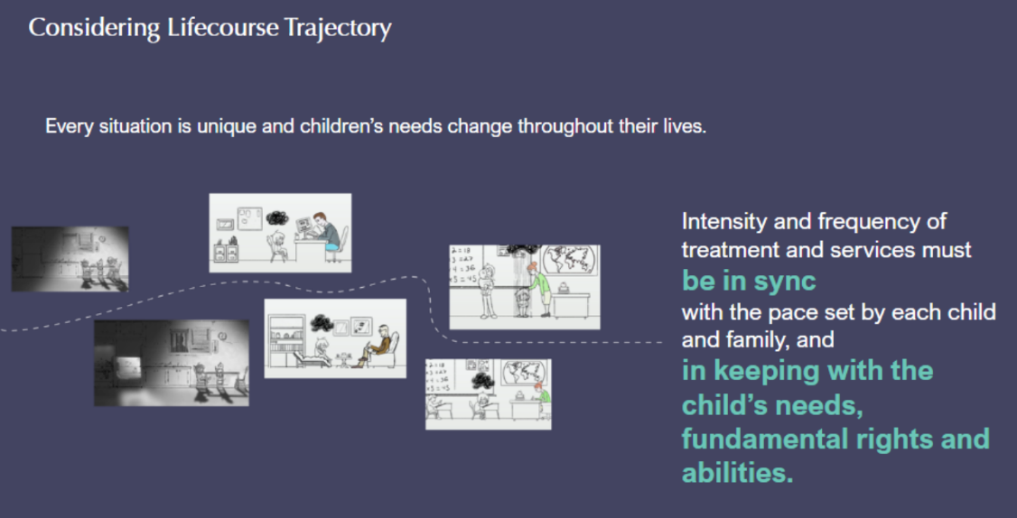
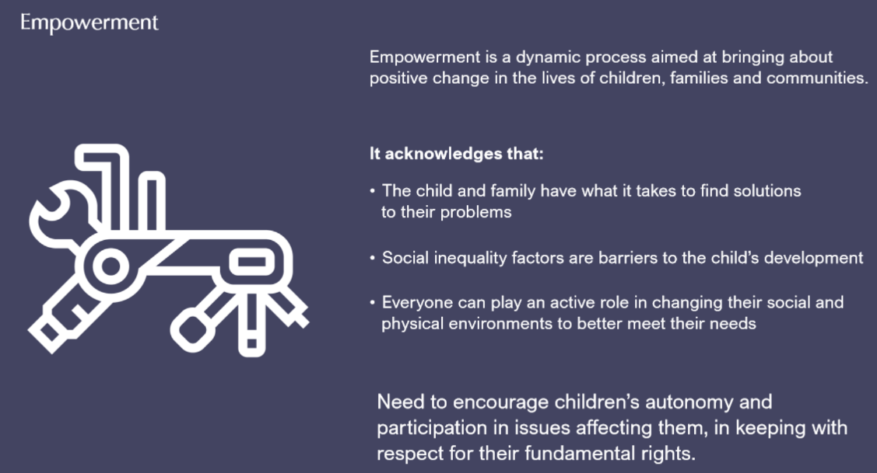
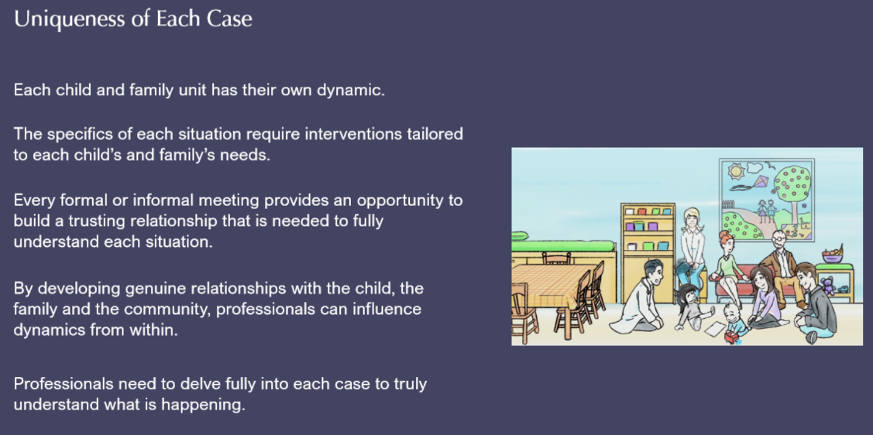
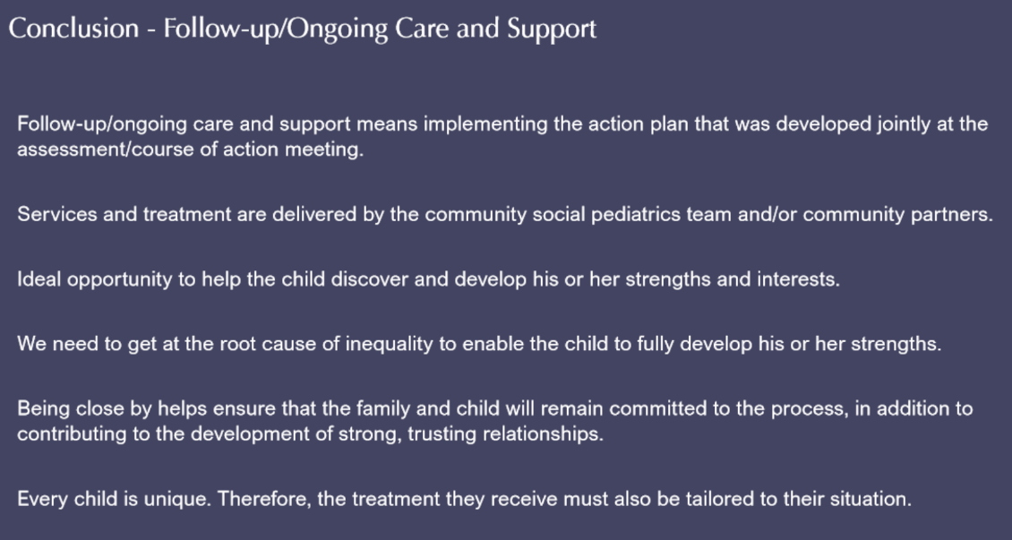
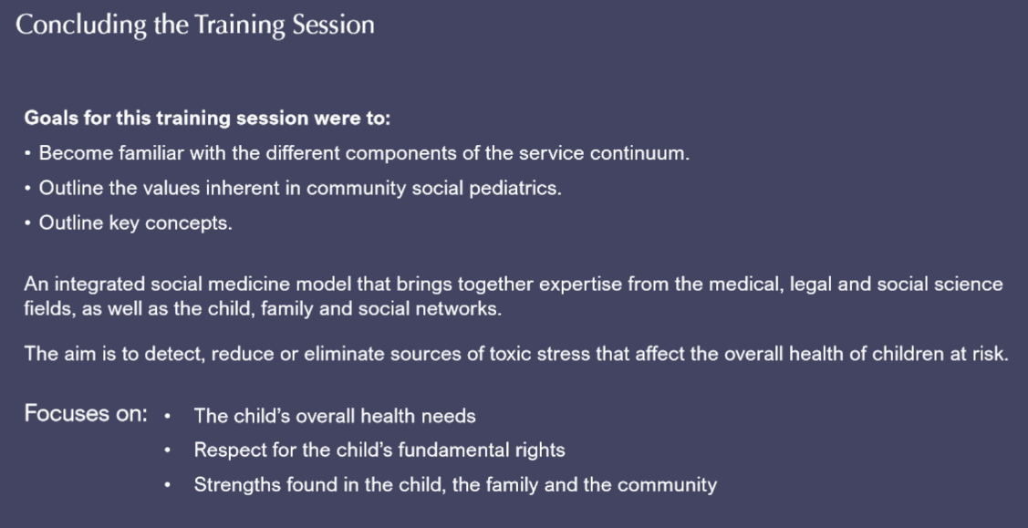
Concluding the Training Session (Continued)

Pre-assessment determines whether a child is at risk.

The welcoming children phase is warm, friendly and informal. The doctor and social worker go into the reception area to greet the family and the child.

The assessment/course of action meeting focuses on:

- Sources of toxic stress
- Unmet needs
- Rights being denied
- Strengths
- Attachment
- Resilience

The action plan is implemented by follow-up/ongoing care and support professionals in collaboration with community groups.

The action plan is re-examined and modified throughout the child’s lifecourse trajectory.

The EEDA method (Establishing, Exchanging, Decoding and Action):
- Builds a solid, trusting relationship
- Makes it easier to share information
- Promotes a common understanding
- Leads to an integrated and concerted action plan.

