CSPI Training Programs
Table of Contents
The Community Social Pediatrics Institute 3
Our mission 3
Our three types of training 3
Our team 3
Continuing Professional Development 4
Training courses 5
CSPC start-up 5
CSPC In development 6
CSPC regular 1 7
CSPC regular 2 8
CSPC regular 3 9
Professions 10
Medecine and Nursing 10
Social work 11
Law 12
Follow-up/support 13
Administration 14
Client reception 15
1. Introductory program 16
1.1 Introduction to Community Social Pediatrics 16
1.2 The Seven Principles of the Rights of the Child 17
1.3 Toxic Stress and Intervention Strategies 18
1.4 Clinical Observation 19
2. Professional Development Program 20
2.1 ADHD and Behavioural Problems 20
2.2 Anxiety Disorders in Vulnerable Children 21
3. Peer Learning Program 22
3.1 Clinical Exchange 22

The Community Social Pediatrics Institute
The CSP approach was developed by Dr. Gilles Julien, a pediatrician, in the 1990s with the collaboration of numerous partners in health and social services, schools and communities. In the 2000s, Hélène (Sioui) Trudel, lawyer and mediator, enriched the CSP model by developing tools to promote access to justice and ensure the respect of all rights enshrined in the Convention on the Rights of the Child. To achieve this, the model relies on the active participation of the child and their family, and an approach based on prevention and conflict resolution. Since then, this model of integrated social medicine has attracted attention from more and more communities and professionals working with children in difficulty. In order to disseminate the knowledge it has acquired through shared experience and social innovation, Fondation Dr Julien created the Community Social Pediatrics Institute.

Our mission
The Community Social Pediatrics Institute contributes to building a community of practice anchored in respecting all of the fundamental rights enshrined in the Convention on the Rights of the Child. It provides the necessary tools by offering training for anyone interested in integrating the spirit and knowledge of CSP in their professional or personal life, either in Quebec or elsewhere in the world. This model of integrated social medicine uses a collaborative and engaged approach to care for, support and provide tools to vulnerable children in order to prevent and counter the impact of toxic stress on their health and development.

Our three types of training
Continuing Professional Development
University Training
Community Training

Our team

Administration:
- Myriam Hivon – Director, Community Social Pediatrics Institute

Design team:
- Anthony Bergeron – Instructional Designer, Continuing Professional Education
- Céline Desjardins – Instructional Designer, University Certificate
- David Guillemette – Instructional Technology Specialist and responsible for the Training Portal

Coordination team:
- Caroline Chaumont – Coordinator, FER (Familles-Enfants-Réseaux)
- Ketty Marradi – Training Coordinator and responsible for internships

Research:
- Marie-Ève Turcotte – Advisor, Scientific Support for Practice Improvement

Content experts:
- Dr. Gilles Julien – pediatrician, Clinical Director and founder of CSP
- Dr. Gaëlle Vekemans – pediatrician, Assistant Clinical Director
- Hélène (Sioui) Trudel – lawyer, mediator, Director of Integrated Law and Social Innovation, and co-founder of Fondation Dr Julien
- The teams of the Hochelaga-Maisonneuve and Côte-des-Neiges CSPCs
- The team at Garage à musique, specialized CSPC
- The teams of designated CSPCs
- The teams of the Hochelaga-Maisonneuve and Côte-des-Neiges CSPCs
- The team at Garage à musique, specialized community social pediatrics centre
- The teams of designated community social pediatrics centres

Continuing Professional Development
The Community Social Pediatrics Institute offers a continuing professional development program designed especially for professionals in the health sciences, social sciences and legal fields who work at, or in partnership with, community social pediatrics centres (CSPCs).
Aimed at fostering continuous improvement in practice, our programs are offered in a variety of online, in-person and hybrid learning formats that we continually update in response to the needs of our different target publics.
Our Continuing Professional Development comprises three components.

Introductory Program
This program is the starting point for any practice in CSP. Its objective is to ensure that all professionals working in the CSP network have a common understanding of the approach.

All new employees in a CSPC must complete the training modules of the Introductory Program listed in their profile before advancing to other training programs. For physicians, completing the Introductory Program is required by Quebec's Ministère de la Santé et des Services sociaux.

Professional Development Program
The goal of this program is to enrich your CSP practice by acquiring a deeper understanding of themes specific to the approach. Bringing together experts in the field of child vulnerability, it helps clinicians update their knowledge and refine their interventions on themes specific to CSP.

Peer Learning Program
In this program, you will strengthen your practice by participating in codevelopment and exchange activities with other professionals. These activities are led by experts and centre around a theme that changes each year.

For new employees at CSPCs, this provides a space for collective learning and experience sharing with colleagues in the network.

Most of our training programs are recognized by Médecins francophones du Canada (French physicians of Canada), the Ordre des travailleurs sociaux et des thérapeutes conjugaux et familiaux du Québec (Quebec’s order of social workers and family/marriage therapists), and the Barreau du Québec (Quebec’s bar association).

For more information on our Continuing Professional Development program, please contact: formation@pediatriesociale.org .

Training courses

CSPC start-up
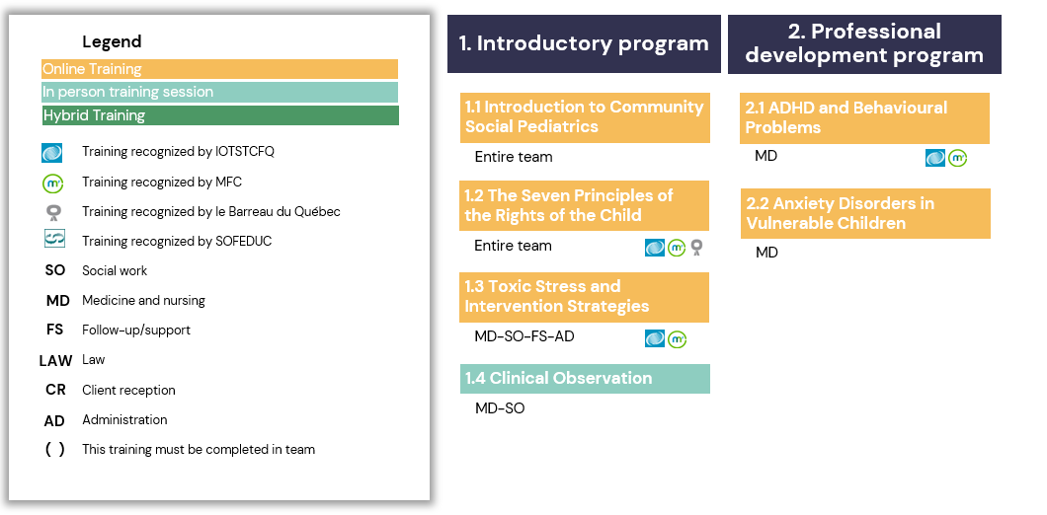

CSPC In development
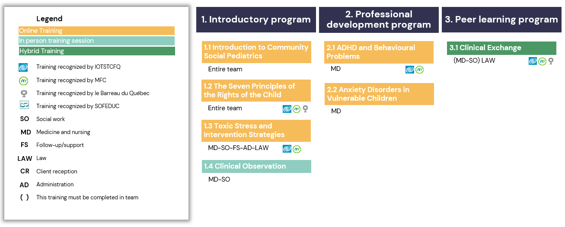

CSPC regular 1
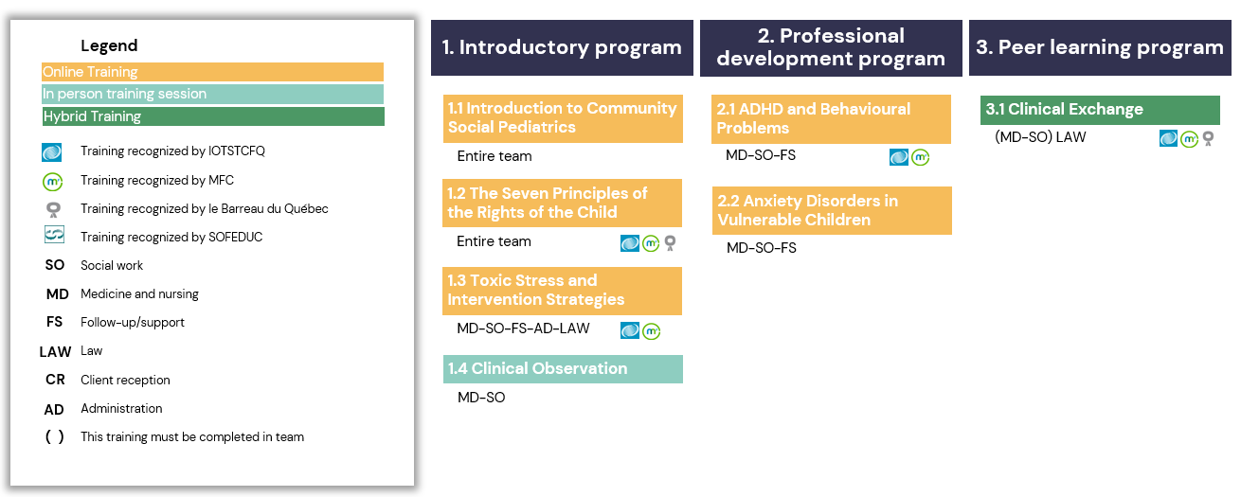

CSPC regular 2
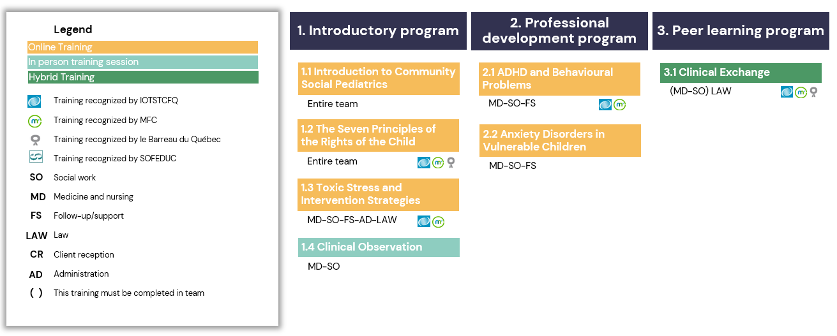

CSPC regular 3
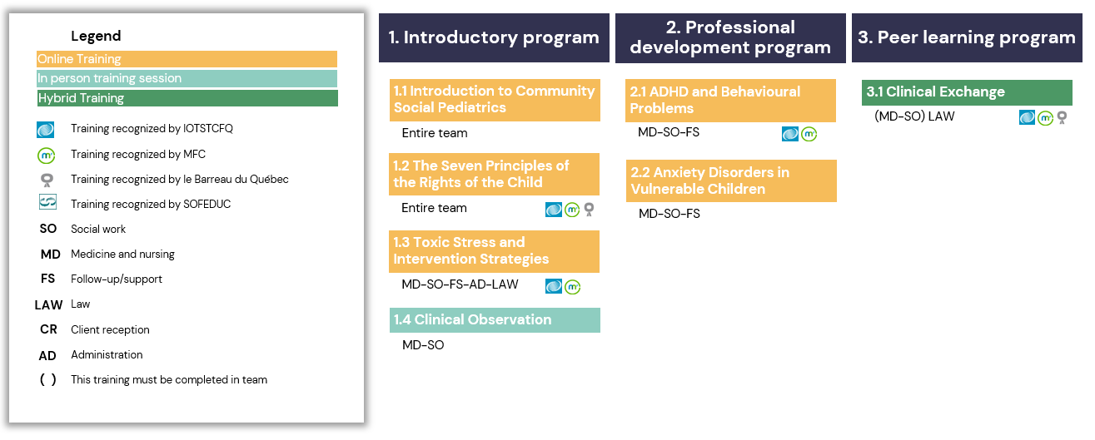

Professions

Medecine and Nursing

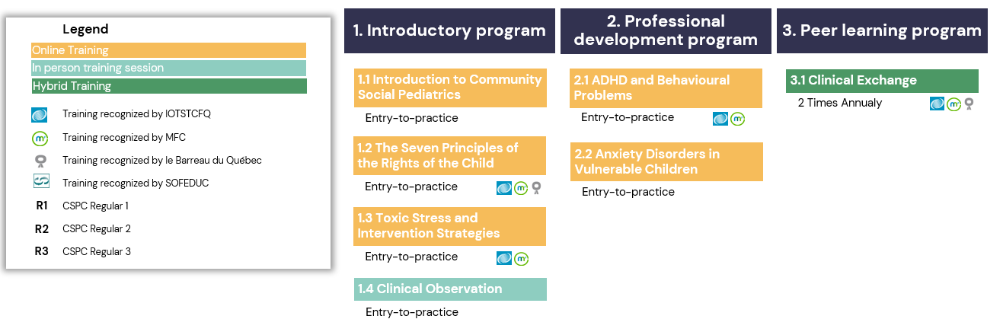

Social work
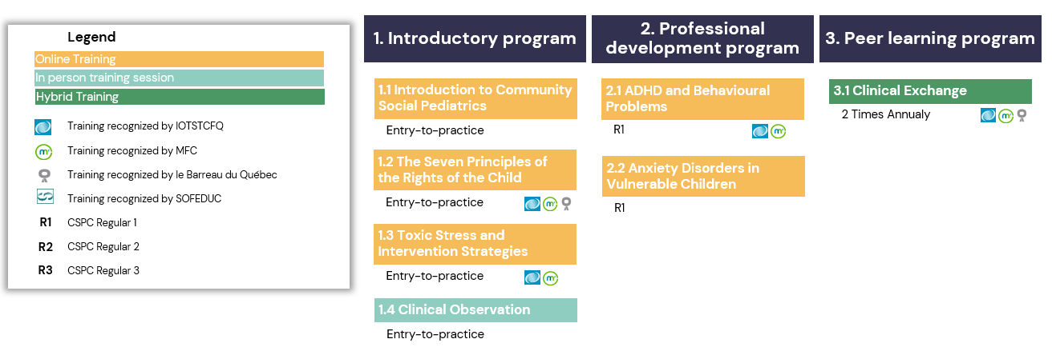

Law
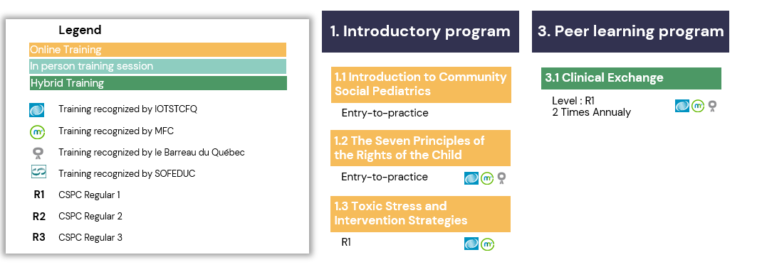

Follow-up/support

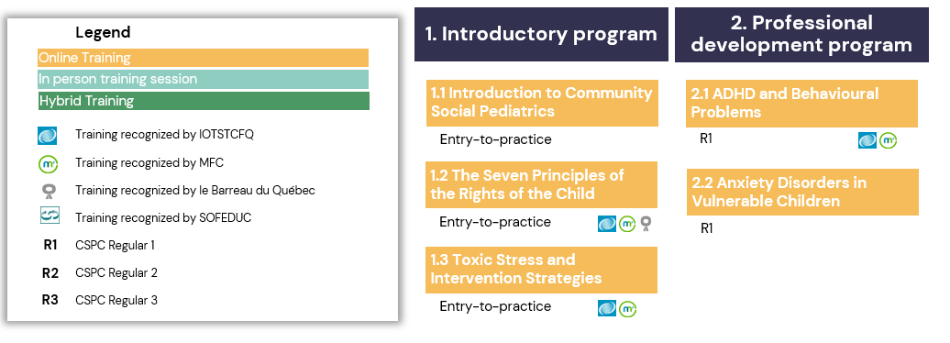

Administration

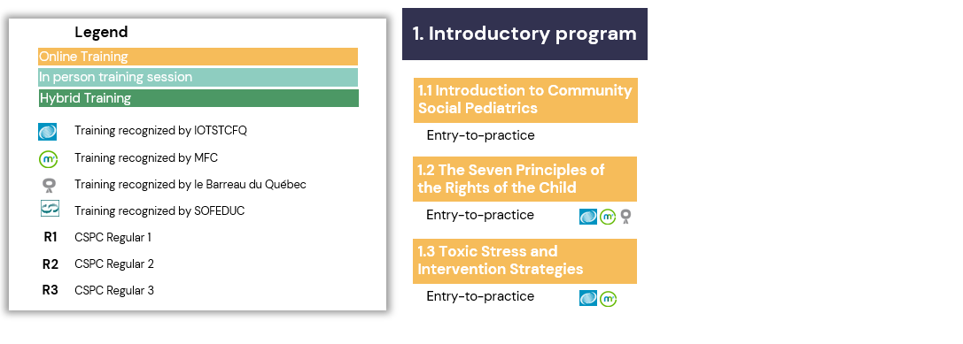

Client reception

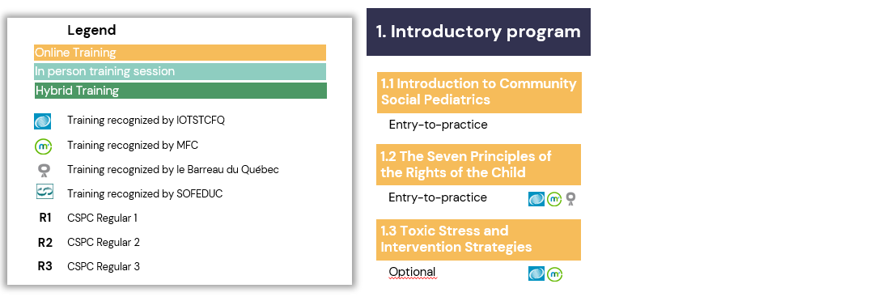

1. Introductory program

1.1 Introduction to Community Social Pediatrics
For professionals in:

Medicine

Nursing

Social work

Law

Follow-up/support

Administration

Client reception

Prerequisites: None

Duration: 60 minutes

Format: Online module
Recognized by:

Ordre des travailleurs sociaux et des thérapeutes conjugaux et familiaux du Québec
- Médecins francophones du Canada
- Barreau du Québec

Description:
CSP is a model of integrated social medicine developed by Dr. Gilles Julien. The approach combines expertise in medicine, law and the social sciences to address situations of multiple trauma. The goal is to identify, reduce and/or eliminate sources of toxic stress that impact the development and well-being of children in difficult living conditions.

This training provides an overview of the main themes specific to CSP by following the story of Mélissa. Through this interactive journey, you discover the main themes, clinical approach, service continuum, unique features, philosophy and values of CSP.

Objectives:
- Understand the key concepts underlying CSP
- Become familiar with the different steps in the service continuum
- Identify the values specific to CSP

Training team:
- Dr. Gilles Julien – pediatrician, Clinical Director, founder of CSP and Fondation Dr Julien
- Hélène (Sioui) Trudel, C.Q., LL.M. – founding Director of Integrated Law and Social Innovation, and co-founder of Fondation Dr Julien
- The team of the Community Social Pediatrics Institute

1.2 The Seven Principles of the Rights of the Child
For professionals in:

Medicine

Nursing

Social work

Law

Follow-up/support

Administration

Client reception

Prerequisites: 1.1 Introduction to Community Social Pediatrics

Duration: 90 minutes

Format: Online module

Recognized by: (2 training hours)

Ordre des travailleurs sociaux et des thérapeutes conjugaux et familiaux du Québec
- Médecins francophones du Canada
- Barreau du Québec

Description:
Professionals working in social pediatrics encounter children suffering from complex health problems: language delays, motor deficits, poor social skills, severe learning disabilities and behavioural problems. But hidden beneath these difficulties are often sources of stress that result in a violation of one or more of the child’s fundamental rights. In order to ensure a child’s full health and well-being, professionals in social pediatrics rely on, among other things, the Convention on the Rights of the Child and its global intervention strategy for ensuring all children can develop to their full potential. In this sense, the Convention is an indispensable tool for enriching the practice of social pediatrics and influences the actions it takes to help children in difficult living conditions.

This online training is an introduction to the Convention on the Rights of the Child. Participants familiarize themselves with the articles of the Convention, learn how these form the basis of the Seven Principles of the Rights of the Child that are used in CSP, and learn to make a link between children’s needs and potential violations of their rights.

Objectives:
- Link the articles of the Convention on the Rights of the Child to the Seven Principles of the Rights of the Child that are used in CSP
- Describe the Seven Principles of the Rights of the Child
- Recognize when the fundamental rights of a child in a situation of vulnerability are being violated

Training team:
- Hélène (Sioui) Trudel, C.Q., LL.M. – founding Director of Integrated Law and Social Innovation, and co-founder of Fondation Dr Julien
- Malika Saher – lawyer and mediator, Fondation Dr Julien
- The team of the Community Social Pediatrics Institute

1.3 Toxic Stress and Intervention Strategies
For professionals in:

Medicine

Nursing

Social work

Law

Follow-up/support

Administration

Prerequisites:

1.1 Introduction to Community Social Pediatrics

1.2 The Seven Principles of the Rights of the Child

Duration: 90 minutes

Format: Online module

Recognized by: (1 training hour)

Ordre des travailleurs sociaux et des thérapeutes conjugaux et familiaux du Québec
- Médecins francophones du Canada

Description:
Increasingly research in neuroscience is focusing on the impact of stress on child development. It is showed that prolonged activation of stress response systems can disturb the development and architecture of the brain and other systems in the body. This can lead to delays in development, detrimental effects on learning and an increased risk of developing certain diseases and cognitive problems in adulthood.

Children living in vulnerable situations often experience strong, frequent and prolonged adversity. Their response to the stress caused by this adversity can become toxic and prevent them from developing to their full potential. The goal of CSP is to identify, reduce and/or eliminate these sources of toxic stress or their underlying risk factors. Identifying and understanding these sources is therefore essential to the practice of social pediatric professionals: it enables them to make sense of the child’s difficulties and then implement effective care and services.

Objectives:
- Understand the links between stress and brain development
- Describe the impacts of stress on brain development, global development and the health of children in situations of vulnerability
- Recognize the sources of toxic stress for children in situations of vulnerability
- Recognize the levers used in CPS to reduce and/or eliminate sources of toxic stress for children in situations of vulnerability

Training team:
- Marie-France Marin, PhD – Assistant Professor–Researcher, Department of Psychology, UQAM
- Dr. Julie Bélanger – family physician, CPSC La Ruelle, Hochelaga-Maisonneuve, Montreal
- Maude Julien – nurse and Director, CPSC de Lévis
- The team of the Community Social Pediatrics Institute

1.4 Clinical Observation
For professionals in:

Medicine

Nursing

Social work

Prerequisites:
- Starting to practice in a CSPC

1.1 Introduction to Community Social Pediatrics

1.2 The Seven Principles of the Rights of the Child

1.3 Toxic Stress and Intervention Strategies

Duration: 7 hours

Format: Direct in-person observation in a training CSPC
- 1 day of clinical observation lasting 7 hours, to be repeated as needed

Registration: Contact the coordinator of clinical observations to reserve your day (formation@pediatriesociale.org)
Details:
- This is a one-time training session to be taken before beginning your clinical practice; it can be repeated as needed
- This training is mandatory for all doctors who wish to practice in CSP

Description:
To be completed before starting practice if possible, this day of clinical observation helps professionals become familiar with the clinical approach of “assessment–course of action” in CSP.

Assessment and determining course of action happens at the meeting between the CSP team (physician, social worker) and the child, accompanied by their family and other significant persons in their life.

The goal is to identify all of the child's needs – physical, social, intellectual, emotional, cultural and spiritual – along with the child’s strengths and interests, in order to draw up an integrative action plan that is adapted to the child’s unique reality and respects the Convention on the Rights of the Child. This process takes into account the child’s life trajectory in all its complexity.

Objectives:
- Put into practice the clinical approach used in CSP
- Integrate the attitudes and methods of assessment–course of action in order to effectively apply EEDA (Establishing, Exchanging, Decoding and Action)
- Identify the key elements of the CSP conceptual framework: toxic stress, children's needs, violation of rights, cultural variables, and the strengths of the child and their family and community

Training team:
- CPSC la Ruelle, Hochelaga-Maisonneuve, Montreal
- CPSC Atlas, Côte-des-Neiges, Montreal
- Le Garage à Musique, Hochelaga-Maisonneuve, Montreal
- CPSC de Gatineau and CPSC du Vieux-Hull
- CPSC Lévis

2. Professional Development Program

ADHD and Behavioural Problems
For professionals in:

Medicine

Nursing

Social work

Follow-up/support

Prerequisites:

1.1 Introduction to Community Social Pediatrics

1.2 The Seven Principles of the Rights of the Child

1.3 Toxic Stress and Intervention Strategies

Duration: 90 minutes

Format: Online module

Recognized by: (2 training hours)

Ordre des travailleurs sociaux et des thérapeutes conjugaux et familiaux du Québec
- Médecins francophones du Canada

Description:
There are many reasons why children in situations of vulnerability often have difficulties with attention and exhibit behaviours deemed difficult or problematic. In order to properly help such children, it is important to distinguish between more transient problems and those caused by actual neurological deficits. This module begins by examining the causes and signs of ADHD and behavioural disorders. Possible comorbidities that can accompany these disorders are also covered. Finally, case studies are used to examine the interventions favoured by CSP for children with these disorders.

Objectives:
- Recognize and identify the signs of ADHD and behavioural disorders
- Describe the comorbidities that can accompany these disorders
- Recognize the biological and environmental sources of these disorders for children in situations of vulnerability
- Understand the levers used in CSP to help children with these disorders

Training team:
- Dr. Leila Ben Amor – child psychiatrist, Department of Psychiatry, Université de Montréal
- Dr. Anne-Marie Bureau – family physician and Director, CPSC de Gatineau and CPSC du Vieux-Hull
- Maude Julien – nurse and Director, CPSC Lévis
- The tram of the Community Social Pediatrics Institute

Anxiety Disorders in Vulnerable Children
For professionals in:

Medicine

Nursing

Social work

Follow-up/support

Prerequisites:

1.1 Introduction to Community Social Pediatrics

1.2 The Seven Principles of the Rights of the Child

1.3 Toxic Stress and Intervention Strategies

Duration: 90 minutes

Format: Online module

Description:
Children and teens in vulnerable situations experience numerous sources of toxic stress. This daily exposure to stress is associated with a number of problems, in particular anxiety disorders. Such disorders can affect the child’s well-being as well as their capacity to function in different areas of their lives and cope with setbacks. For professionals in CSP, it is essential to distinguish between signs of anxiety disorder and signs of other disorders, and then implement the most appropriate action plan.

Objectives:
- Recognize the signs of anxiety disorders in children and teens in situations of vulnerability
- Explore and try out clinical tools to help children, teens and families in situations of vulnerability cope with and/or overcome anxiety disorder

Training team:
- Dr. Gilles Julien– pediatrician, Clinical Director, founder of CSP
- Michèle Lambin – social worker, psychoeducator, instructor and supervisor
- The team of the Community Social Pediatrics Institute

3. Peer Learning Program

3.1 Clinical Exchange
Intended for professionals in:

Medicine

Nursing

Social work

Prerequisites:
- Be a professional in a CSPC undergoing certification, Regular 1, 2 or 3

Introductory Program

Duration: 6 to 9 hours

Format: Hybrid format

2 to 3 half-days of online clinical exchange

Recognized by: (6 to 9 training hours)

Ordre des travailleurs sociaux et des thérapeutes conjugaux et familiaux du Québec
- Médecins francophones du Canada
- Barreau du Québec

Description:
The goal of clinical exchange is to strengthen the skills of clinical teams in assessment–course of action. These teams are usually composed of physicians, social workers, nurses, lawyers and mediators.

Based an annual theme, selected clinical teams present a complex case that participants then discuss in a round table format.

These exchanges provide an opportunity to analyze, in an interdisciplinary way, challenging situations faced by CSP professionals in their practice. They help identify avenues for intervention and foster reflection that strengthens their practice. Through these exchanges and the sharing of experiences, clinical teams also reinforce their skills in communication, collaborative intervention and the decoding of verbal and nonverbal language, all essential competencies in CSP.

Objectives:
- Resolve clinical questions encountered by participants
- Stimulate a reflective posture on the practice of community social pediatrics.
- Foster mutual support between professionals working in CSPCs

Training team:
- Dr. Gilles Julien – pediatrician, Clinical Director, founder of CSP
- Hélène (Sioui) Trudel, C.Q., LL.M. – founding Director of Integrated Law and Social Innovation, and co-founder of Fondation Dr Julien
- Dr. Anne-Marie Bureau – family physician and Director, CPSC de Gatineau and CPSC du Vieux-Hull
- Maude Julien – nurse and Director, CPSC Lévis
- Dr. Gaëlle Vekemans – pediatrician and Assistant Clinical Director, CPSC la Ruelle and CPSC Atlas, Montreal
- The teams of CSPCs in Lévis, Gatineau, Hochelaga-Maisonneuve and Côte-des-Neiges

